**CS 457/557 -- Winter Quarter 2021**

**Project #5**

**Image Manipulation in a "Magic Lens"**

**Name: Chun-Yu Chen**

**E-mail:** [**chench6@oregonstate.edu**](mailto:chench6@oregonstate.edu)

* **What I did and explaining why it worked this way:**

1. Use if/else to determine what range I need to do the magnification, rotation, and sharpness.
2. Calculate the magnification then give the result of vec2 to the rotation part to continually calculate the new s and t.
3. After getting the new s and t, put them into the sharpness section to get the final result.
4. Set another model as circle, then use the concept of Project1(s-sc)2 / Ar2 + (t-tc)2 / Br2 = 1) to get the range I need to filter.

* 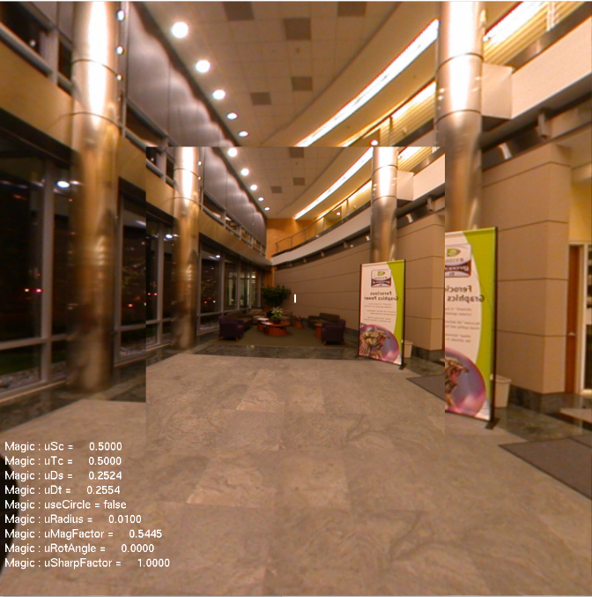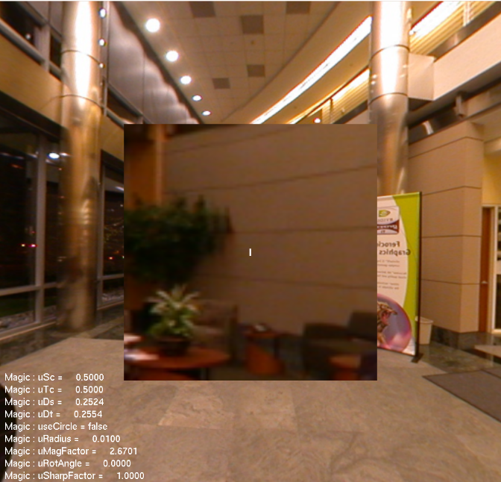**Screen shots from program:**

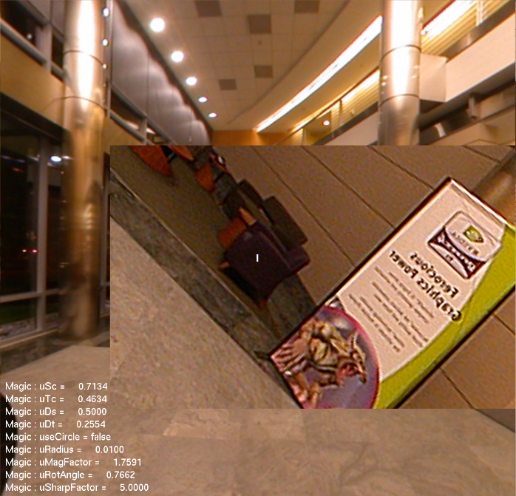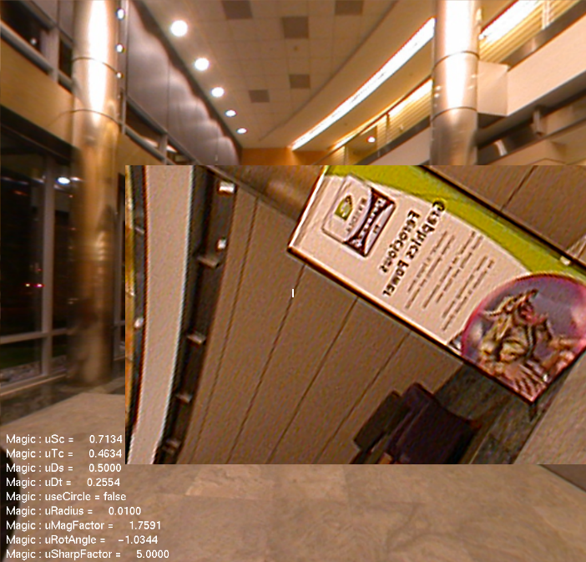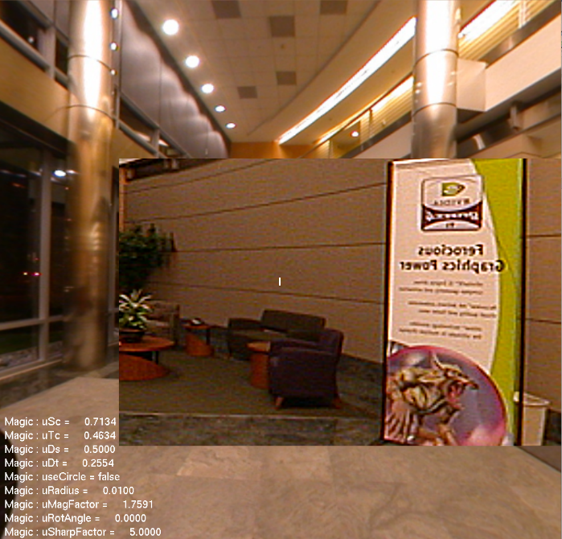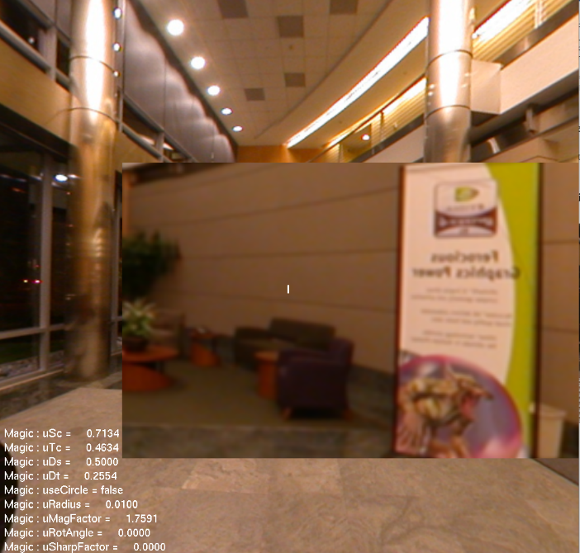

* **Video Link:** [**https://youtu.be/X1kRHZW-x_Q**](https://youtu.be/X1kRHZW-x_Q)